# File permissions in Linux

## Project description

In this project, we are examining and managing the permissions of files in the researcher2 projects directory. This includes changing permissions of directories, hidden files and so on.

## Check file and directory details

Figure 1:Listing File Directories and permissions

## Describe the permissions string

Using the project_k.txt file the first string is a “- “, this shows that it is just a file and not a directory. The next three strings are “r”, “w” and “- “, which indicates that the owner “user” has read and write permissions, but not the execute permission. The 5th to 7th string are “r”, “w” and “- “, showing that the owner type “group” has read and write permissions, but not the execute permission. The 8th to 10th string are “r”, “w” and “- “, showing that the owner type “other” has read and write permissions, but not the execute permission.

## Change file permissions

Figure 2: Removing write permission from owner other in project_k.txt

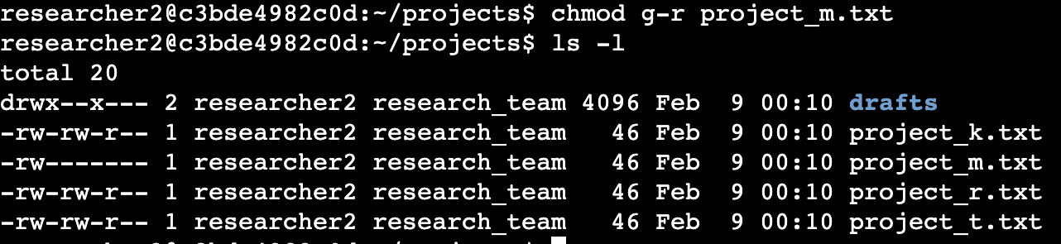

Figure 3: Removing read permissions from owner group in project_m.txt

## Change file permissions on a hidden file

Figure 4: Listing all files and permissions including hidden files



Figure 5: Changing the write and read permissions on user and group of the hidden file project_x.txt

## Change directory permissions

Figure 6: Removing Execute permission from the owner group in the drafts directory

## Summary

The chmod command is a useful Linux command in cybersecurity to manage file and directory permissions.